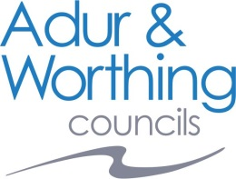 |  | Property Search  Public Health & Regulation Data  Send completed form to: Adur & Worthing Councils, Public Health & Regulation, Portland House, 44 Richmond Road, Worthing, BN11 1HS  web: www.adur-worthing.gov.uk  email: publichealth.regulation@adur-worthing.gov.uk
Property Address:
Postcode:
Please return this form to the address below by email, post or in person
Your Name:
Company Name:
Address:
Postcode:
Tel No:
Email address:
The question numbers relate to the Local Land Charges CON 29 Form
Information Required: * please tick / delete as appropriate
3.7 Outstanding Notices
Do any statutory notices which relate to the following matters subsist in relation to the property other than those revealed in a response to any other enquiry in this form:
(a) building works Yes * No *
(b) environment Yes * No *
(c) health and safety Yes * No *
(d) housing Yes * No *
(f) public health Yes * No *
3.13 Contaminated Land
Do any of the following apply (including any relating to land adjacent to or adjoining the property which has been identified as contaminated land because it is in such a condition that harm or pollution of controlled waters might be caused on the property):
(a) a contaminated land notice; Yes * No *
(b) in relation to a register maintained under section 78R of the Environmental Protection
Act 1990
(i) a decision to make an entry; or Yes * No *
(ii) an entry; or Yes * No *
(c) consultation with the owner or occupier of the property conducted under section 78G(3)
of the Environmental Protection Act 1990 before the service of a remediation notice?
Yes * No *

