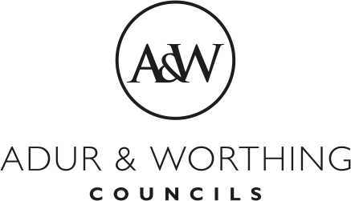 | Pre-Application Advice Form  [Charges from 2 May 2023]

Applicant Name and Address:
Title
Forename(s)
Surname
Address
Postcode
Phone number
E-mail address

Agent Name and Address:
Title
Forename(s)
Surname
Address
Postcode
Phone number
E-mail address

Site Address:
Address
 |  | Postcode
Is the site accessible to the Planning Officer without prior arrangement?  If not, please provide details of an appropriate contact. |  |  | Yes
 |  |  | No
Name
Phone number

Proposed Development

Type of pre application advice required
please put a X against the relevant Pre-application advice
Householder Extensions  Extensions over 100 sqm  Initial written advice based on a desk top study. | £100 (inclusive of VAT)  £175 (inclusive of VAT)  A subsequent meeting or further written response with Officers will be charged at the above rate.
‘Minor’ Residential development of  1-4 dwellings  or  Commercial floor space up to 999 sqm.  Initial written advice based on a desk top study. | Fixed Fee £500 + VAT  A subsequent meeting or further written response with Officers will be charged at the above rate.
Residential Development of  5-9 dwellings  or  Commercial floor space between  1,000-4,999 sqm.  Up to 1 hour meeting on site or at the Council offices followed up by written advice. | Fixed Fee £700 + VAT  Any additional meeting or further written response with Officers will be charged at the above fixed fee.
‘Major’ Residential Development of  10-49 dwellings  Commercial floor space of 5,000 to 9,999 sqm.  Up to 1 hour meeting on site or at the Council offices followed up by written advice | Fixed Fee £1,000 + VAT  Fixed Fee of £850 + VAT  Any additional meeting or further written advice with Officers will be charged at the above fixed fee.
Significant Major Residential Development  50+ dwellings  100 dwellings and above  Commercial floor space of more than 10,000 sqm.  Up to 1 hour meeting on site or at the Council offices followed up by written advice. | Fixed Fee £1,500 + VAT  Fixed Fee £3,000 + VAT  Fixed Fee £1,500 + VAT  Each additional meeting with Officers will be charged at the above fixed fee.
Change of Use  Listed Buildings  (where extensions are proposed)  Advertisements | Fixed Fee £150 +VAT  Fixed Fee £150 + VAT  Fixed Fee £150 + VAT
Trees | Fixed Fee £150 + VAT
General Advice on Discharge  Of Conditions or s106 provisions: | Fixed Fee £150 + VAT
We will not deal with your enquiry until the appropriate fee is paid.

Payments can be made by debit/credit card by phoning 01903 221230, Monday to Friday between 10am and 4pm or by BACS, details below. Please use the address as a reference.

Adur applications | Worthing applications
Account Name: Adur District Council | Account Name: Worthing Borough Council
Sort Code: 30-80-12 | Sort Code: 30-80-12
Account No: 11766960 | Account No: 11723668

I have paid the appropriate fee | Yes |  |  | No

I enclose the relevant supporting documentation as outlined in the Pre-Application Advice Scheme: please tick or put an X in the relevant box(es)

Location and Site Plans
Sketch or Indicative Plans of the Proposal (including photographs where appropriate).
Supporting Studies/Information (where relevant for major schemes)

Signature

Date

